Data in GIS

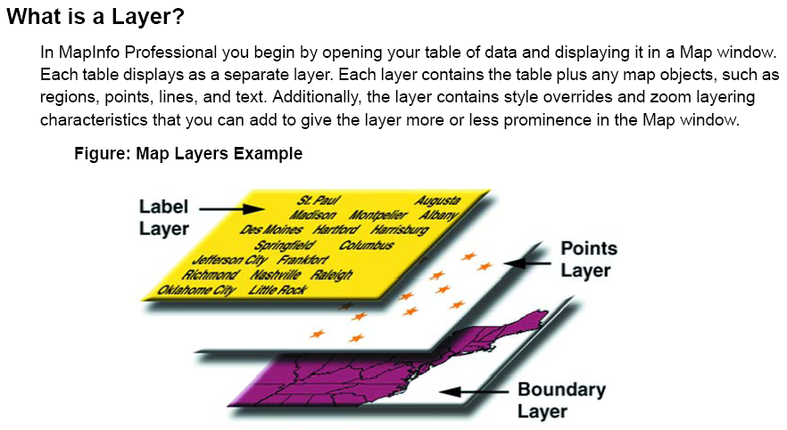

Map Objects as Part of Layers

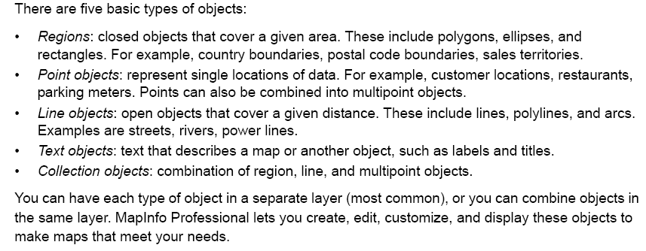

A Brief Tour of MapInfo GIS
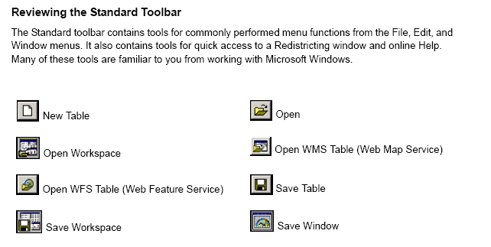
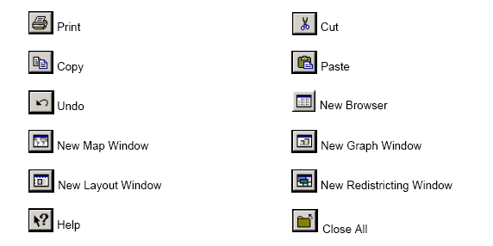

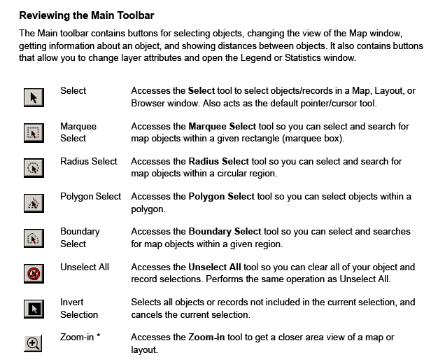

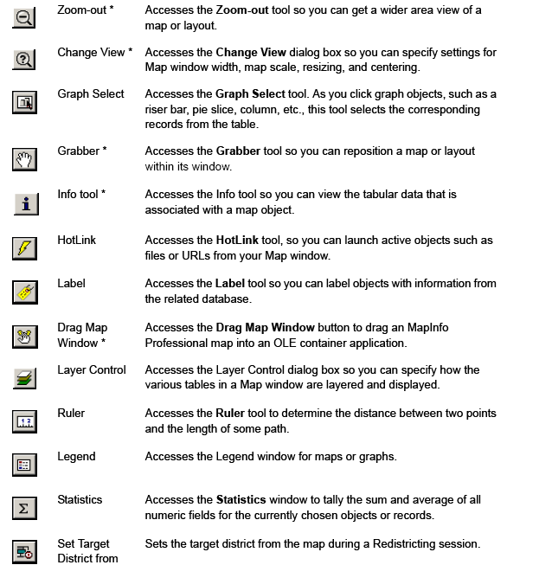
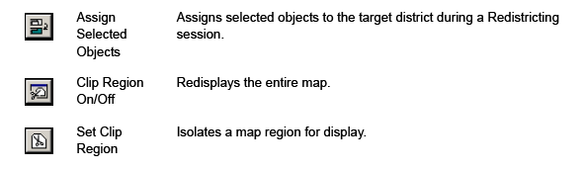

Reviewing the Drawing Toolbar
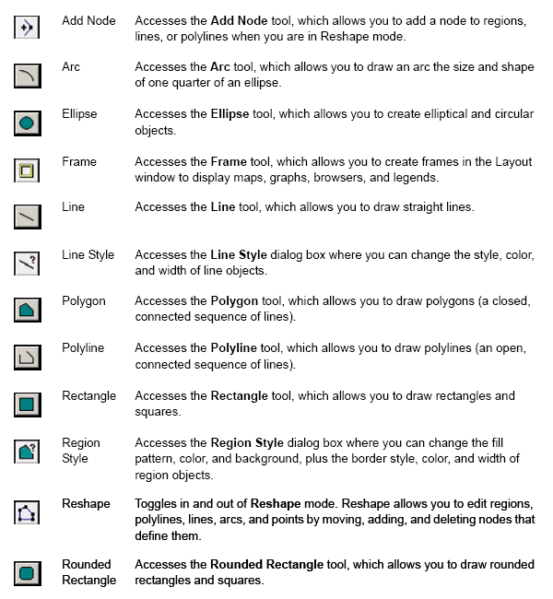

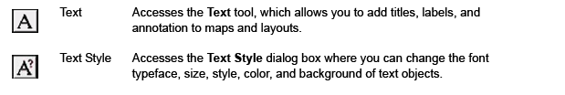

Example 1 – Damansara Data

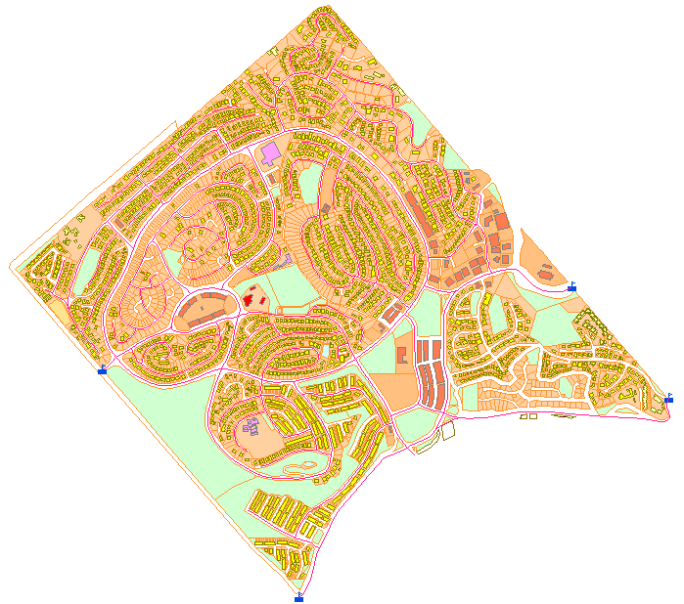

The map that you see consists of three layers of information arranged on top of one another. These are:
- Lot layer
- Building layer
- Road layer

Use tools to add, remove, arrange the order of the layers.

You can also create new layers (see in later classes).

What do you have in each layer?

Each layer comes with a table. This table contains the attribute information – the textual descriptions relating to the objects (or features) found in that layer.

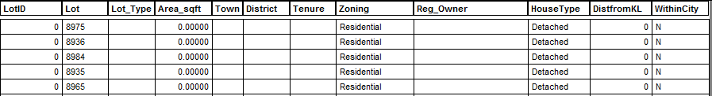

Each row represents a record for an object (feature).

Each column represents a field of the record.

You can add, delete or edit information in the table (see later classes).
Exercise

Using the Damansara data, practise opening and organising the layers of information. Try out the tools to familiarise yourself with each and the tasks each performs. Note down the menu that you will use in order to perform specific operations.

